
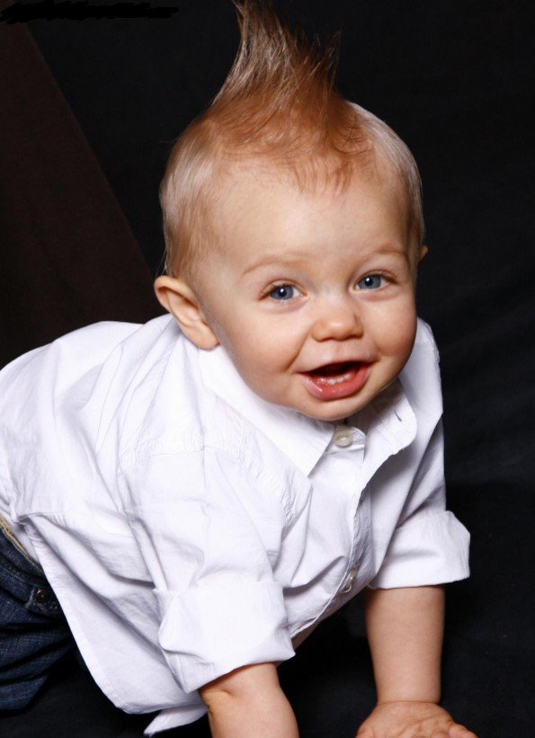

Beautiful Faces of GA
Model & Talent
Open State Competition
February 20&21st, 2009
New Location!!
Ramada Atlanta Airport Conference Center
1380 Virginia Ave
Atlanta, GA 30344

About us

BFG is a natural modeling competition that celebrates NATURAL BEAUTY. Our judging panel consists of agents from the top modeling and talent agencies in the Southeast. Launched in August of 2004 we have helped over 400 contestants from all over GA and the SE to be discovered and signed. Many have already been cast in major print ad campaigns, catalogs, commercials, and a few have even landed roles in major motion pictures! These were regular kids just like your child that had a special spark and were seen and discovered by the right people. No classes or portfolios are needed or required. We use only reputable booking agencies that make money by finding your children work. We do not use or promote agencies that solicit for classes or portfolios. All you need at BFG is a pretty face and a great smile!

Pageant Time and Registration

Deadline for entry form and $50.00 deposit is postmark February 6th, you can pay balance in cash at rehearsal. Rehearsal will be on Fri. February 20th on a drop in basis from 6-9pm but is not required if entry, and balance is paid in full. Girls & Boys ages 0-6 will compete and be awarded before 7-up competition and awards.

Age Divisions
Girls
0-2years 3-4 years 5-6 years
7-9 years 10-12 years 13-15 years 16-up

Boys
0-2years 3-4years 5-6 years 7-10 years
11-15 years 16-up

Awards
Age division winners will receive a $500.00 savings bond, a 6 ft trophy and recognition on the BFG website, and a Model management contract with Kids for Casting Model & Talent for a year.
All children not placing will receive a large trophy. No one leaves empty handed. Natural beauty & photogenic scores are added to determine winners of each group.

Overall Awards
There will be two overalls, one for ages 0-6 years and one for ages 7 and up.
The overall winner is the contestant that has the highest scores of all the other contestants in their overall brackets (0-6 or 7+) .The overall winners will receive a $1000.00 savings bond, 8 ft trophy and a model management contract with Kids for Casting Model & Talent for a year.
Natural beauty & photogenic scores are added to determine winner of overalls.

Talent
Talent is an optional title and is not required for overall awards. Time limit is 3 minutes and is your choice. You may dance, sing, recite, or play an instrument. Music (CD Only) must be labeled and ready to play. There will be a talent winner for each age group and the winner will receive a trophy. There will be two overall talent winners
(0-6 & 7-up) Overall talent winners will receive a huge trophy and a $200.00 savings bond!

Optional Awards
We will award a photogenic award, and best personality in each age division. Each optional winner will receive a trophy. Pictures must be submitted with entry form or the night of rehearsal and be no larger than 8 x 10. One picture is included in price, extra pictures will be $10.00 each extra. Natural pictures are required, snapshots, and outdoor shots are preferred .No touched up photos allowed.

Model of the Year
This is an optional competition and will be judged during model competition. There will be two winners, one in 0-6 years and one in 7-up. The judges will pick the child they feel has the most marketability and the most promise as a child model. The winner will receive a large trophy and a FREE PHOTO SHOOT with a top photographer!

Sponsor Tickets
Sponsor tickets are a great way to pay for your entry fees and win great awards. Ask your friends, family, and local businesses to sponsor you for $2.00 per ticket. Every contestant collecting $400.00 in sponsor tickets will receive their entry fee paid for all events in competition, a 4ft trophy, and an awesome gift on stage. The contestant with the most sponsorships collected will be awarded the title of “Beautiful Faces of GA Ambassador” and receive their entry fees paid to all events in competition, a 7ft trophy, a gift, and be recognized on BFG with picture and bio . All sponsorship tickets must be turned in no later than February 10th, 2009 to qualify for awards.
Tickets will be submitted into drawings for awesome prizes!

Referrals
Referrals are a great way to make new friends and pay your fees also! Refer 3 friends who have never done a Beautiful Faces competition and you get to enter FREE!

Attire & Judging
Attire will be any type of blue jean bottom and a white top of your choice. Jeans may have design but denim must be blue. Shirts may have trim but all trim must be white also. No make up for contestants 0-12 and only minimal make up for contestants 13-up Remember we want to see your NATURAL beauty. All contestants will be judged based on first impression, natural beauty, and personality. Judges will be from top model & talent agencies and will be scouting for new talent to represent.
Contestants scouted will be notified the day of the competition.
Score sheets will be available after the competition

Door Admission
Armbands will be pre-sold the night of rehearsal and on the day of competition
Armbands must be worn at all times the day of the competition
One parent free with contestant. Adults- $10.00, Students- $5.00.
Children 4 and under admitted free.

Sister discount
One child pays full price and 1 sibling enters for $50.00 off! Siblings must reside in same residence.
(Only 1 sibling discount may be used)

Entry Form

Registration fee (includes 1 armband, DVD & pictures of competition) $50.00 _____

Entry fee (includes 1 photogenic picture) $200.00 ____

Extra pictures $10.00 each x _____ $_______
Model of the Year $25.00______
Talent (if competing in model competition) $25.00______
Total ___________ $50.00 dep. Mandatory by Feb. 6th, balance can be paid on Feb 20th ___________
Balance Due _____________
Sponsorship Tickets sold #_______
Please Print

Child’s Name_____________________________________ Age______________ DOB____________________ M/F____
Address_______________________________________________
City______________________ Zip Code__________________
Phone#___________________________
Email_________________________________________________
Parent/s names__________________________________________
Eye Color_________________ Hair Color__________________
Hobbies & Talent_________________________________________
_______________________________________________________
Favorite TV Show or Actor_________________________________
Ambition________________________________________________
________________________________________________________
Sponsored By_____________________________________________
Referred By_______________________________________________

I hereby certify that Beautiful Faces of GA, , staff, and facility where pageant or event is being held, or anyone associated with this event are not responsible for accidents, injury, or theft incurred before, during, or after the pageant and therefore release any liability to said parties. Judges decisions are final. Poor sportsmanship will result in disqualification of contestant and prizes (this includes contestant and family members). The director reserves the right to cancel event due to lack of participation with full refund. I understand no refund will be given if contestant fails to show or is disqualified because of misconduct by contestant or family member. Deposits of any kind are non- refundable. There must be at least five or more contestants in age division to award savings bond. There must be 50 in competition to guarantee overall bonds.

Parent Signature___________________________________________Date__________
Contestant Signature ( if 18 or over)_________________________________

Mail Entries with check or money order to:

Beautiful Faces of GA

PO Box 100 , Orchard Hill, GA 30266
Questions please call Mrs. Monica Daniels : 770-412-6201
Please make all checks and money orders out to: Beautiful Faces of GA

Competition & Host Hotel
Ramada Inn Atlanta Airport Conference Center
1380 Virginia Ave, Atlanta, GA 30344
Reservation: 1-800-316-6241
Special Rates: BFG Model Expo rate $79.00 per night
Competition will take place at Host Hotel
You must tell them you are with BFG for special rate

